**MIND MAZE : THE 2D PLATFORMER QUEST**

**PROJECT REPORT**

**Submitted By**

**ABRAHAM JORDAN GEORGE (Reg No : MCT22MCA-2003)**

**APJ Abdul Kalam Technological University**

In partial fulfilment of the requirement for the award of the

Degree of

**MASTER OF COMPUTER APPLICATIONS**

**DEPARTMENT OF COMPUTER APPLICATIONS**

**MOHANDAS COLLEGE OF ENGINEERING AND TECHNOLOGY**

**Anad, Nedumangadu, Thiruvananthapuram**

**695541**

**2024**

**DEPARTMENT OF COMPUTER APPLICATIONS**

**MOHANDAS COLLEGE OF ENGINEERING AND TECHNOLOGY**

**Anad, Nedumangadu, Thiruvananthapuram-695544**

**CERTIFICATE**

This is to certify that the main project report entitled **“MIND MAZE: THE 2D PLATFORMER QUEST”** submitted by **ABRAHAM JORDAN GEORGE (Register No: MCT22MCA-2003)** to **APJ Abdul Kalam Technological University** in partial fulfilment of the requirement for the award of the degree **MASTER OF COMPUTER APPLICATIONS** is bonafied record of the project work carried out by her under my guidance and supervision. This report in any form has not been submitted by any other University or Institute for any purpose.

Internal Supervisor(s) Project Coordinator

Head of the Department Internal Examiner

**DECLARATION**

I undersigned hereby declare that the main project report **“MIND MAZE: THE 2D PLATFORMER QUEST”**, submitted for partial fulfilment of the requirements for the award of degree of Master of Computer Applications of the APJ Abdul Kalam Technological University, Kerala is a bonafide work done by me under supervision of Prof. Rekha M. Pillai. This submission represents my ideas in my own words and where ideas or words of others have been included, I have adequately and accurately cited and referenced the original sources.

I also declare that I have adhered to academic honesty and integrity ethics and have not misrepresented or fabricated any data, idea, fact, or source in my submission. I understand that any violation of the above will be a cause for disciplinary action by the Institute and or the University and can also evoke penal action from the sources which have thus not been properly cited, or from whom proper permission has not been obtained. This report has not been previously formed as the basis for the award of any degree, diploma, or similar title of any other university.

Place: Thiruvananthapuram ABRAHAM JORDAN GEORGE

Date:

**ACKNOWLEDGEMENT**

I am overwhelmed in all humbleness and gratefulness to acknowledge in depth all those who have helped me to put these ideas, well above the level of simplicity into something concrete. I would like to express my special thanks and gratitude to our principal Dr. S. SHEELA and our Director Dr. ASHALATHA THAMPURAN for providing all the necessary facilities.

I am greatly thankful to Prof. SREEJA K, (HOD, Department of Computer Applications) for her kind cooperation and guidance throughout the course of my project.

I am also thankful to my Guide Prof. Rekha M. Pillai, (Associate Professor, Department of Computer Applications) for her kind cooperation and guidance throughout the course of my pro-ject.

I would also like to acknowledge the contributions of my people from discord and other communities who have been a source of motivation and encouragement throughout this project.

Last but certainly not least, I would also like to thank all the staff of the Department of Com-puter Applications for their help and cooperation.

With Gratitude

ABRAHAM JORDAN GEORGE

TABLE OF CONTENTS

ABSTRACT 1

1. INTRODUCTION 2
   1. ABOUT THE PROJECT 2
   2. OBJECTIVE 3
   3. SCOPE 3
   4. EXISTING SYSTEM 4
   5. PROPOSED SYSTEM 5
2. METHODOLOGY 6
   1. AGILE METHODOLOGY 6
   2. ROLES 6
   3. IMPLEMENTATION 7
   4. PRODUCT BACKLOG 8
   5. SPRINT BACKLOG 10
   6. FEASIBILITY STUDY 11
      1. TECHNICAL FEASIBILITY 11
      2. FINANCIAL FEASIBILITY 12
      3. LEGAL FEASIBILITY 12
      4. OPERATIONAL FEASIBILITY 13
3. REQUIREMENT SPECIFICATION 14
   1. HARDWARE REQUIREMENTS 14
   2. SOFTWARE REQUIREMENTS 14
   3. FUNCTIONAL REQUIREMENTS 15
   4. NON-FUNCTIONAL REQUIREMENTS 16
4. TECHNOLOGY 17
   1. OVERVIEW…………………………………………………………………………..17
   2. ALGORITHM…………………………………………………………………………19
5. SYSTEM DESIGN 23
   1. WORK FLOW ARCHITECTURE 23
   2. USECASE DIAGRAM**……………………………………………………………….**24
   3. MAJOR FUNCTIONALITY 25
6. SYSTEM TESTING 27
   1. TEST CASE 27
   2. SYSTEM MAINTENANCE 28
      1. MAINTENANCE SCHEDULE 29
7. CONCLUSION 30
8. FUTURE ENHANCEMENT 31
9. RESULTS 33
   1. GANTT CHART 33
   2. SCREENSHOTS 34
10. BIBILIOGRAPHY 37
11. REFERENCES 38

ABSTRACT

A 2D platformer game developed using Java programming language and GIMP for graphics. The game immerses players in a captivating adventure through intricately designed levels filled with obstacles and enemies. Key features include meticulously crafted level designs, intuitive player controls, and dynamic enemy behaviors. The incorporation of GIMP allows for visually stunning graphics and animations, enhancing the overall gaming experience. Additionally, audio integration provides immersive sound effects and background music. Through this project, the importance of creativity, problem-solving, and collaboration in game development is highlighted. The game offers an engaging and entertaining experience suitable for players of all ages, showcasing the potential of Java and open-source tools in game development.

1. **INTRODUCTION**

**1.1 ABOUT THE PROJECT**

The modern era has seen a significant rise in the popularity of digital gaming as both a form of entertainment and as a tool for education. In this context, the development of 2D puzzle platformer games has emerged as a captivating genre that offers players not only an immersive gaming experience but also opportunities for learning and skill development. This project endeavors to contribute to this landscape by introducing a 2D puzzle platformer game developed in Java.

The game presented in this project offers players a dynamic and engaging experience as they navigate through a series of levels replete with puzzles and trivia challenges. Designed with the aim of fostering problem-solving skills, critical thinking, and knowledge acquisition, the game tasks players with overcoming obstacles and unlocking doors by adeptly solving puzzles or correctly answering trivia questions.

With each level presenting unique challenges, ranging from math puzzles to word scrambles, trivia quizzes, pattern matching, and riddles, players are continually challenged to employ a diverse set of cognitive abilities to progress through the game. The incorporation of intuitive controls, educational elements such as math problems and general knowledge trivia, and visual and auditory feedback mechanisms further enhances the gaming experience, ensuring both enjoyment and intellectual stimulation for players of all ages and backgrounds.

This project not only showcases the potential of game development as an educational and recreational medium but also underscores the importance of cultivating essential skills in a stimulating and enjoyable format. By offering a game that is suitable for deployment in educational environments or as a standalone entertainment product, this project aims to contribute to the growing body of educational gaming resources available to individuals seeking both entertainment and intellectual enrichment.

**1.2 OBJECTIVE**

The primary objective of this project is to develop a 2D puzzle platformer game using Java that offers players an engaging and immersive gaming experience while also serving as an educational tool. The game aims to challenge players' problem-solving skills, critical thinking abilities, and general knowledge through a series of diverse puzzles and trivia challenges. Additionally, the project seeks to highlight the potential of game development as a medium for promoting intellectual stimulation and learning in an enjoyable and interactive format. Through intuitive controls, educational elements, and visual and auditory feedback mechanisms, the game aims to provide players of all ages and backgrounds with an entertaining and intellectually rewarding experience. Ultimately, the project aims to contribute to the growing body of educational gaming resources available to individuals seeking both entertainment and intellectual enrichment.

**1.3 SCOPE**

The scope of this project encompasses the development of a 2D platformer game using Java, focusing on providing players with an engaging and educational gaming experience. The project will include the design, implementation, and testing of various game elements, including levels, puzzles, controls, and user interface components.

**Key features to be implemented within the scope of the project include:**

* Designing and creating multiple levels with unique challenges, such as math puzzles, word scrambles, trivia quizzes, pattern matching, and riddles.
* Developing intuitive controls for seamless gameplay, including character movement and interaction with in-game objects.
* Integrating educational elements into the game, such as math problems, vocabulary building, and general knowledge trivia.
* Implementing visual and auditory feedback mechanisms to guide players and provide insights into their progress.
* Testing the game for functionality, usability, and overall player experience, ensuring that it meets the project objectives and quality standards.
* The project will focus on delivering a fully functional prototype of the 2D puzzle platformer game that demonstrates the core gameplay mechanics, educational elements, and overall entertainment value. While the project may lay the groundwork for future enhancements and additional features, the primary goal is to develop a compelling and enjoyable gaming experience within the specified scope and timeline.

**1.4 EXISTING SYSTEM**

The current landscape of puzzle platformer games offers entertainment value through engaging gameplay mechanics. However, many existing games lack integration with educational elements or fail to provide a diverse range of challenges that promote problem-solving skills, critical thinking, and knowledge acquisition. Furthermore, while some educational games may exist, they often sacrifice entertainment value for educational content, resulting in a less engaging gaming experience.

**Disadvantages of the Existing System:**

* Limited educational value: Existing puzzle platformer games may lack integration with educational elements, missing an opportunity to promote learning and skill development.
* Lack of diversity in challenges: Many games in this genre offer repetitive gameplay mechanics, leading to monotony and decreased player engagement over time.
* Educational games may lack entertainment value: While some educational games exist, they often prioritize educational content over entertainment value, resulting in a less engaging gaming experience for players.

**1.5 PROPOSED SYSTEM**

The proposed system aims to address the limitations of existing puzzle platformer games by integrating educational elements into an immersive gaming experience. The 2D puzzle platformer game developed in Java will offer players a dynamic journey through levels filled with diverse puzzles and trivia challenges, promoting problem-solving skills, critical thinking, and knowledge acquisition.

**Advantages of the Proposed System:**

* Enhanced educational value: By integrating educational elements such as math problems, vocabulary building, and general knowledge trivia into the gameplay, the proposed system promotes learning and skill development in an engaging and interactive format.
* Diverse range of challenges: The game will feature multiple levels with a variety of challenges, including math puzzles, word scrambles, trivia quizzes, pattern matching, and riddles, ensuring a stimulating and dynamic gaming experience for players.
* Balancing entertainment and education: Unlike existing educational games that may sacrifice entertainment value for educational content, the proposed system aims to strike a balance between entertainment and education, offering players an enjoyable and intellectually stimulating gaming experience.
* Overall, the proposed system seeks to offer players an entertaining and intellectually rewarding gaming experience, bridging the gap between entertainment and education within the puzzle platformer genre.

1. **METHODOLOGY**
   1. **AGILE METHODOLOGY**

For my final year academic project, I implemented Agile methodology to manage the develop-ment of Mind Maze: The Puzzle Platformer Quest. Agile methodology is a project management framework that emphasizes flexibility, collaboration, and continuous improvement. This report describes the process of implementing Agile in my project and discuss the benefits, challenges, and lessons learned. Agile teams work in short cycles called sprints, with each sprint delivering a working increment of the project.

* 1. **ROLES**

For my final year academic project on Mind Maze: The Puzzle Platformer Quest, I decided to implement Agile methodology to ensure that I could work efficiently and effectively. Since I was working alone, I adapted the roles of the team members to fit my needs.

Head of Department, Prof Sreeja K, acted as my designated Scrum master, helped to facilitate meetings and ensure that I followed the Scrum framework.

Prof. Rekha M. Pillai, served as my product owner, providing guidance on the project goals and priorities.

* 1. **IMPLEMENTATION**

In implementing the Agile methodology for this project, we embraced the iterative and collaborative principles of Scrum to drive the development of our 2D puzzle platformer game. We structured our work into manageable sprints, each typically lasting one to two weeks. At the start of each sprint, we held planning sessions to prioritize tasks and define the sprint backlog. Daily stand-up meetings provided a forum for the team to synchronize efforts, discuss progress, and address any obstacles hindering productivity. These brief but frequent check-ins ensured that everyone stayed on track and focused on achieving our sprint goals.

Throughout the development process, we prioritized continuous integration and testing to maintain the quality of our codebase. Automated testing was leveraged to detect bugs early on, allowing us to address issues swiftly and ensure the stability of our game. At the end of each sprint, we conducted thorough reviews to showcase our progress to stakeholders and gather feedback. These insights were invaluable in shaping our next steps and refining our approach in subsequent sprints.

Moreover, the Agile approach afforded us the flexibility to adapt to changing requirements and priorities as the project evolved. We welcomed feedback from stakeholders and play testers, incorporating their insights to improve the game's design and functionality iteratively. By embracing collaboration, communication, and incremental delivery, we were able to deliver a polished and engaging 2D puzzle platformer game that not only met but exceeded our initial project objectives.

* 1. **PRODUCT BACKLOG**

|  |  |  |  |  |  |
| --- | --- | --- | --- | --- | --- |
| **ID** | **As a…** | **I want to be able to…** | **So that..** | **Priority** | **Remarks** |
| 1 | Player | Move the character using keyboard inputs | I can navigate through the game world, evade obstacles, and explore different areas effectively | High |  |
| 2 | Player | Interact with objects in the game world | I can solve puzzles, trigger mechanisms, and progress through levels by unlocking doors and accessing new areas | High |  |
| 3 | Player | Answer trivia questions correctly | I can unlock doors, access bonus content, and gain rewards such as power-ups or collectibles | High |  |
| 4 | Developer | Implement collision detection | Player interactions with objects, enemies, and the environment are accurately detected, ensuring smooth gameplay and preventing unintended glitches | High |  |
| 5 | Developer | Design diverse levels with unique challenges | Each level offers a fresh and engaging experience, keeping players motivated and immersed in the game | High |  |
| 6 | Developer | Integrate educational elements | Players can enhance their cognitive abilities & expand their knowledge | High |  |
| 7 | Player | Receive visual and auditory feedback on progress and actions | I can understand my performance, track my progress, and make informed decisions to improve my gameplay strategy | Medium |  |
| 8 | Player | Have a progression system that increases difficulty with each level | I am continuously challenged, motivated, and rewarded as I progress through the game, fostering a sense of accomplishment and mastery | Medium |  |
| 9 | Developer | Test the game for functionality, usability, and overall player experience | Any issues, bugs, or inconsistencies are identified, addressed, and resolved to ensure a polished and enjoyable gaming experience for players | Medium |  |
| 10 | Developer | Optimize game performance for smooth gameplay | The game runs smoothly on various devices and platforms, providing players with a seamless and immersive gaming experience without lag or performance issues | Medium |  |
| 11 | Player | Access game settings to customize controls, audio, and display options | I can tailor the game experience to my preferences, ensuring optimal comfort and accessibility | Low |  |
| 12 | Developer | Implement a save/load system to allow players to resume their progress | Players can save their game state and continue playing from where they left off, enhancing convenience and replayability | Low |  |
| 13 | Player | View leaderboards to compare my performance with other players | I can gauge my skills and progress against others, fostering competition and motivation | Low |  |
| 14 | Developer | Implement a tutorial or hints system to assist players | New players can quickly learn the game mechanics and overcome challenges, reducing frustration and enhancing the overall experience | Low |  |
| 15 | Player | Access additional content or unlockables as rewards for completing challenges | I am incentivized to engage with the game, explore its content, and strive for completion | Low |  |

* 1. **SPRINT BACKLOG**

|  |  |  |
| --- | --- | --- |
| **Sl. No.** | **User Story** | **Status** |
| 1 | Creating development environment | Completed |
| 2 | Downloading the required Assets | Completed |
| 3 | Learning the algorithm | Completed |
| 3 | Integrate animations for player movement and interactions | Completed |
| 4 | Move character with keyboard | Completed |
| 5 | Interact with objects | Completed |
| 6 | Answer trivia questions | Completed |
| 7 | Implement collision detection | Completed |
| 8 | Design diverse levels | Completed |
| 9 | Receive visual and auditory feedback | Completed |
| 10 | Progression system for level | Completed |
| 11 | Access game settings | Completed |
| 12 | Optimize game performance | Completed |
| 13 | Testing and review | Completed |
| 14 | Documentation | Completed |

* 1. **FEASIBILITY STUDY**

A feasibility study is a preliminary investigation or analysis conducted to evaluate the practicality, viability, and potential success of a proposed project or idea. It is typically conducted at the beginning of a project to determine if it is worthwhile, given the resources, time, and effort required to complete it. The main purpose of a feasibility study is to assess the technical, economic, social, and environmental aspects of a proposed project, and to identify any potential issues, risks, or challenges that may affect its success. This analysis includes gathering and evaluating data, determining project requirements, defining objectives, assessing potential benefits and drawbacks, analyzing the market, and estimating costs and financial returns A feasibility study for implementing Mind Maze: The Puzzle Platformer Quest would involve assessing the technical, financial, legal, and operational aspects of the project. Here are some key considerations to keep in mind:

* + - Technical feasibility
    - Financial feasibility
    - Legal feasibility
    - Operational feasibility

**2.6.1 TECHNICAL FEASIBILITY**

The technical feasibility study assesses whether the game's development can be achieved using available technology and resources, considering factors such as resource availability, development team expertise, compatibility with target platforms, and scalability

* Resource Availability: Evaluate the availability of hardware, software, and development tools specifically required for game development.
* Skill Set: Assess the development team's expertise in Java programming, game development, and relevant frameworks necessary for implementing the game.
* Compatibility: Determine if the game can be developed to run smoothly on various platforms such as Windows, macOS, and Linux without technical constraints.
* Scalability: Evaluate the game's architecture to ensure it can accommodate future updates, expansions, and additional features without compromising performance or stability.

**2.6.2 FINANCIAL FEASIBILITY**

The financial feasibility study analyzes the project's costs, revenue potential, and expected ROI to determine if the game development is financially viable.

* Cost Estimation: Estimate the development costs including licensing fees, development tools, hardware, personnel expenses, and other associated costs.
* Revenue Projection: Analyze potential revenue streams such as game sales, in-game purchases, advertisements, or subscriptions to assess the game's revenue potential.
* Return on Investment (ROI): Calculate the expected ROI based on revenue projections and development costs to determine the profitability of the game project.

**2.6.3 LEGAL FEASIBILITY**

The legal feasibility study ensures that the game's development complies with copyright laws, intellectual property rights, licensing agreements, and regulatory standards.

* Copyrights and Intellectual Property: Ensure that all game assets, code, and content used in the project are legally obtained and properly licensed to avoid copyright infringement issues.
* Licensing Agreements: Verify the legality and compliance of third-party libraries, frameworks, and assets used in the game with relevant licensing agreements.
* Regulatory Compliance: Consider legal requirements related to game development, distribution, and monetization in target markets to ensure compliance with applicable laws and regulations.

**2.6.4 OPERATIONAL FEASIBILITY**

The operational feasibility study evaluates the practicality and viability of the game project in terms of user acceptance, resource allocation, support and maintenance, and market analysis.

* User Acceptance: Assess potential players' interest and preferences through surveys or focus groups to ensure the game concept, mechanics, and features align with player expectations.
* Resource Allocation: Evaluate the availability of human resources, time, and infrastructure required for game development, testing, and maintenance to ensure smooth project execution.
* Support and Maintenance: Plan for ongoing support, updates, and maintenance post-launch to address issues, introduce new features, and ensure the game remains engaging and relevant to players.
* Market Analysis: Conduct market research to understand the competitive landscape, target audience demographics, and market trends to position the game effectively and maximize its success in the market.

This comprehensive feasibility study will provide valuable insights into the viability and potential success of the game project, helping stakeholders make informed decisions and mitigate risks effectively.

1. **REQUIREMENT SPECIFICATION**
   1. **HARDWARE REQUIREMNETS**

|  |  |  |
| --- | --- | --- |
| Processor | : | Intel(R) Core(TM) i3-1005G1 CPU  @ 1.20GHz 1.19 GHz |
| RAM | : | 2 GB or Above |
| Hard Disk | : | 512 GB or Above |
| Internet | : | 4Mbps or above (Wired or Wireless) |
| Display | : | 15.5” Color Monitor |
| Screen Resolution | : | 1366 x 768 x 60 Hz |
| Color Palette | : | True Color (32 bit) |

* 1. **SOFTWARE REQUIREMENTS**

|  |  |  |
| --- | --- | --- |
| Operating System | : | Windows, Linux  (Windows 11) |
| Code | : | Java |
| Framework | : | JavaFX |
| Graphics Software | : | GIMP |
| IDEs  Development Kit | :  : | Eclipse  Jdk |

* 1. **FUNCTIONAL REQUIREMENTS**

Contains two modules:

**Player Module**

**FN1 :** Player Controls

Allow the player to move left, right, jump, and interact with the game environment using keyboard inputs or compatible game controller.

**FN2 :** Character Mechanics

Implement physics-based movement for the player character, including acceleration, deceleration, and gravity. Enable the character to jump, double-jump, and perform other actions such as crouching or attacking if applicable.

**FN3 :** Combat Mechanics

If applicable, include combat mechanics such as attacking, jumping on enemies to defeat them, or using special abilities.

**FN4 :** User Interface (UI)

Display essential information such as the player's score, remaining lives, current level, and collected items. Include menus for starting the game, selecting levels, pausing, and quitting.

**FN5 :** Audio and Visual Effects

Provide background music, sound effects for actions such as jumping, collecting items, or defeating enemies. Implement visual effects such as animations, particle effects, and screen transitions.

**System Module**

**FN1 :** Level Design

Create multiple levels with varying layouts, obstacles, enemies, and collectibles. Design each level to provide a progressively challenging experience for the player.

**FN2 :** Obstacles and Hazards

Implement obstacles such as platforms, spikes, pits, moving platforms, and other hazards that the player must navigate or avoid.

**FN3 :** Enemies

Include enemies that the player must defeat or avoid. Implement enemy behavior and interactions with the player.

**FN4 :** Power-Ups and Collectibles

Introduce power-ups, items, or collectibles that provide temporary boosts or unlock new abilities for the player character.

**FN5 :** Accessibility and Options

Provide options for adjusting volume, toggle music, sfx audio, show credits, options to play and quit and esc to return to home screen

* 1. **NON**- **FUNCTIONAL REQUIREMENTS**
* Trivia Integration
* Security
* Localization
* Scalability
* Privacy

1. **TECHNOLOGY**
   1. **OVERVIEW**

Here is an overview of the technology used in Mind Maze: The 2DPlatformer Quest:

**WINDOWS**

Windows, developed by Microsoft Corporation, is a seminal series of operating systems that has profoundly shaped the landscape of computing since its inception in 1985 with the release of Windows 1.0. Offering a graphical user interface (GUI) on top of MS-DOS, Windows introduced users to a new era of computing characterized by intuitive navigation, multitasking capabilities, and a wide array of built-in applications. Over the years, subsequent versions of Windows have continued to innovate, bringing advancements in user interface design, security features, and compatibility with hardware and software. Windows has democratized computing, making it accessible to a broader audience and driving innovation and productivity across industries. Its impact extends beyond technology, influencing societal norms and cultural practices. Today, Windows remains a dominant force in the technology market, continually evolving to meet the evolving needs of users in an increasingly digital world.

**JAVA**

Java, a versatile and powerful programming language, serves as the foundation for creating a dynamic and engaging 2D platformer game. With its platform-independent nature and robust features, Java provides developers with a flexible and scalable environment for game development. Leveraging Java's object-oriented principles, developers can design modular and maintainable code structures, facilitating collaboration and code reuse. The rich ecosystem of libraries and frameworks available in Java, such as Swing or JavaFX for graphical user interface development, enables developers to create visually stunning game environments and responsive user interfaces. Additionally, Java's built-in features for handling input, managing resources, and implementing game logic streamline the development process, allowing developers to focus on crafting immersive gameplay experiences. Overall, Java empowers developers to create high-quality 2D platformer games that are cross-platform compatible, performance-efficient, and enjoyable for players of all ages**.**

**JAVAFX**

JavaFX, a powerful framework for building rich client applications, is instrumental in creating a captivating and interactive 2D platformer game. Offering a comprehensive set of APIs and tools, JavaFX enables developers to create visually stunning user interfaces and engaging graphical experiences. With its support for hardware-accelerated graphics rendering, JavaFX ensures smooth animation and responsive performance, enhancing the overall gaming experience. The scene graph-based architecture of JavaFX allows developers to easily manipulate graphical elements, such as sprites, backgrounds, and UI components, to design dynamic game environments. Moreover, JavaFX provides robust support for multimedia integration, enabling developers to seamlessly incorporate audio and video elements into their games. Combined with Java's platform independence and rich ecosystem of libraries, JavaFX empowers developers to create cross-platform 2D platformer games that are immersive, visually appealing, and enjoyable for players of all ages.

**GIMP (GNU Image Manipulation Program )**

GIMP, an open-source raster graphics editor, plays a pivotal role in crafting visually captivating assets for a 2D platformer game. With its comprehensive set of tools and features, GIMP empowers game developers and designers to create high-quality sprites, backgrounds, and other graphical elements that bring the game world to life. From character animations to level designs, GIMP provides flexible and intuitive tools for drawing, painting, and editing, allowing for endless creativity and customization. Additionally, GIMP's support for layers, filters, and blending modes enables artists to achieve intricate and detailed artwork with ease. The ability to export images in various formats and resolutions ensures compatibility with game development frameworks and platforms. By leveraging the power and versatility of GIMP, developers can enhance the visual appeal of their 2D platformer games, creating immersive and captivating experiences for players to enjoy.

**ECLIPSE**

Eclipse, a widely-used integrated development environment (IDE), serves as a robust tool for developing a 2D platformer game with Java. Offering a comprehensive suite of features, Eclipse provides developers with a seamless development experience, from coding and debugging to testing and deployment. Its intuitive interface and customizable workspace allow developers to efficiently organize and manage their project files and resources. With built-in support for Java development, Eclipse offers powerful code editing capabilities, including syntax highlighting, code completion, and refactoring tools, enabling developers to write clean and maintainable code. Additionally, Eclipse's integrated debugging tools facilitate the identification and resolution of issues, ensuring the stability and reliability of the game.

Furthermore, Eclipse's extensive plugin ecosystem provides access to a wealth of additional tools and resources, further enhancing the development process. Overall, Eclipse serves as an indispensable tool for developers creating 2D platformer games with Java, offering a feature-rich environment for efficient and productive development workflows.

**JDK (Java Development Kit)**

The Java Development Kit (JDK) is an essential component for creating a 2D platformer game using Java. As the core development kit for Java programming, JDK provides developers with all the necessary tools and libraries needed to write, compile, and run Java applications, including games. With JDK, developers have access to the Java compiler, which translates Java source code into bytecode that can be executed by the Java Virtual Machine (JVM). Additionally, JDK includes a comprehensive set of libraries, such as the Abstract Window Toolkit (AWT) and JavaFX, which provide functionality for creating graphical user interfaces (GUIs), handling input/output operations, and implementing game logic. Furthermore, JDK offers development tools like the Java Debugger (JDB) and Java VisualVM, which aid in debugging and profiling Java applications, ensuring smooth and efficient development process. Overall, JDK serves as the foundation for developing 2D platformer games in Java, providing developers with the tools and resources needed to create immersive and engaging gaming experiences.

* 1. **ALGORITHM**

**INITIALIZE GAME ENVIRONMENT**

It involves setting up the foundational elements of the game, including the creation of the game window and graphics context. Using Java's Swing or JavaFX libraries, the game window is initialized with appropriate dimensions and settings to accommodate the gameplay. Additionally, game assets such as background images, character sprites, and level designs created using GIMP are loaded and configured within the game environment.

**GAMELOOP**

The game loop is the central mechanism that drives the flow of the game. It iteratively updates and renders the game state, ensuring a seamless and interactive experience for the player. Within the loop, player input is processed, game objects are updated based on user actions and game logic, collisions are detected and resolved, and the updated game state is rendered to the screen. The game loop operates continuously throughout gameplay, maintaining a consistent pace and responsiveness.

**PLAYER MOVEMENT AND CONTROLS**

The focus is on implementing player movement mechanics and controls. Player input from the keyboard or game controller is captured and interpreted to control the movement of the player character within the game world. Movement mechanics such as acceleration, gravity, and friction are applied to simulate realistic player movement, providing a responsive and engaging gameplay experience.

**COLLISION & DETECTION**

Collision detection is a crucial aspect of game development that ensures the accurate interaction between game objects within the game world. Algorithms are implemented to detect collisions between the player character and other game objects such as platforms, obstacles, enemies, and collectibles. When collisions occur, appropriate collision responses are executed to handle interactions between objects, such as stopping player movement, bouncing off surfaces, or triggering specific actions.

**ENEMY BEHAVIOUR**

This category focuses on defining and implementing the behavior of enemy characters within the game. Enemy behavior patterns and movement mechanics, such as patrolling or chasing, are designed based on game design requirements. AI algorithms are developed to control enemy actions and interactions with the player character, providing challenging and dynamic gameplay encounters.

**LEVEL DESIGN**

Level design encompasses the creation of game levels, including the layout, structure, and environmental elements of each level. Using GIMP, game designers craft visually appealing backgrounds, platforms, obstacles, and other environmental elements to create immersive and engaging gameplay experiences. Level assets are imported into the game and strategically placed within the game world to provide a balanced and progressively challenging gameplay progression.

**GRAPHICS & ANIMATIONS**

Graphics and animations play a vital role in enhancing the visual appeal and immersive quality of the game. Using GIMP, artists create sprite sheets and animations for characters, enemies, and other game objects. These assets are then loaded into the game and animated based on the game state changes, such as player movement or enemy attacks, to provide fluid and lifelike animations that enhance the overall gaming experience.

**AUDIO INTEGRATION**

Audio integration involves the incorporation of background music, sound effects, and audio cues to enrich the auditory aspect of the game. Using Java's sound libraries or external audio frameworks, audio files are loaded and played during gameplay to enhance immersion and atmosphere. Background music sets the tone and mood of the game, while sound effects provide feedback and feedback on player actions and interactions.

USER INTERFACE

The user interface (UI) is the interface through which players interact with the game. UI elements such as menus, buttons, and heads-up displays (HUDs) are designed and implemented using Java's Swing or JavaFX libraries. These elements provide players with relevant game information, such as score, lives, and level progress, and facilitate navigation and interaction within the game.

**TESTING & DEBUGGING**

Testing and debugging are essential phases of the game development process that ensure the quality and stability of the final product. Extensive testing is conducted to identify and fix bugs, glitches, and gameplay issues that may impact the player experience. Playtesting involves playing the game to evaluate its performance, balance, and overall enjoyability, and to gather feedback for further refinement and improvement.

These detailed descriptions provide a comprehensive overview of each category involved in developing a 2D platformer game using Java and GIMP, offering insights into the key components and processes that contribute to the creation of a successful and engaging game experience.

1. **SYSTEM DESIGN**
   1. **WORKFLOW ARCHITECHTURE**

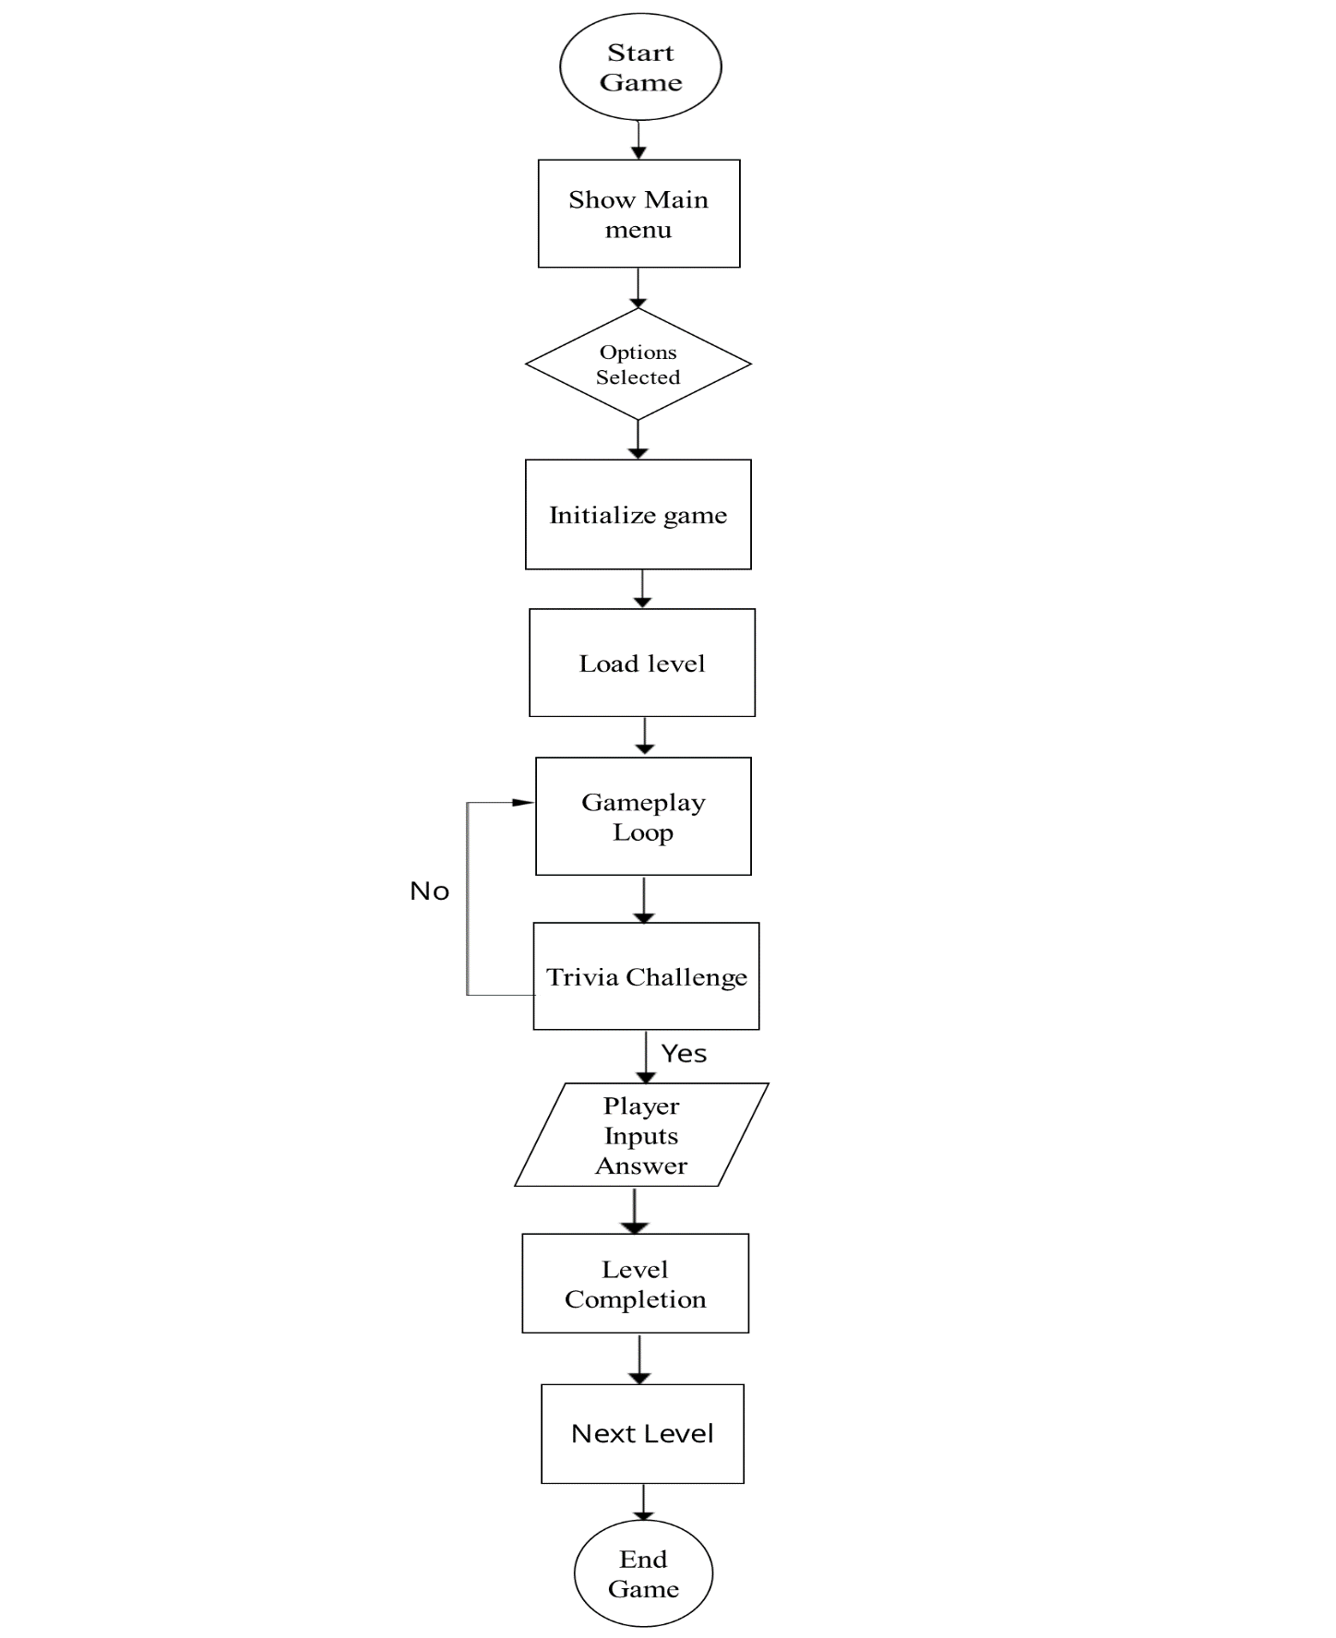

* 1. **USECASE DIAGRAM**

**PLAYER USECASE**

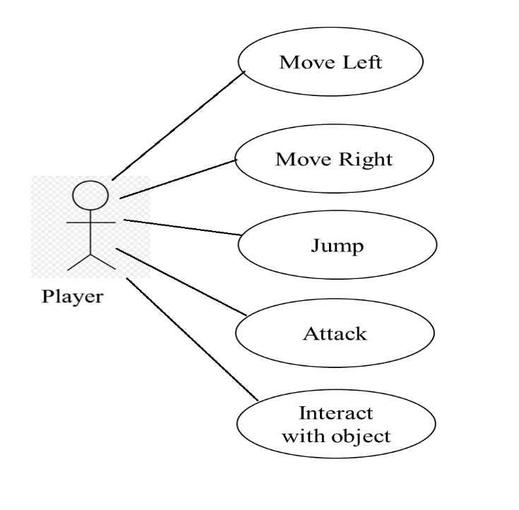

**SYSTEM USECASE**

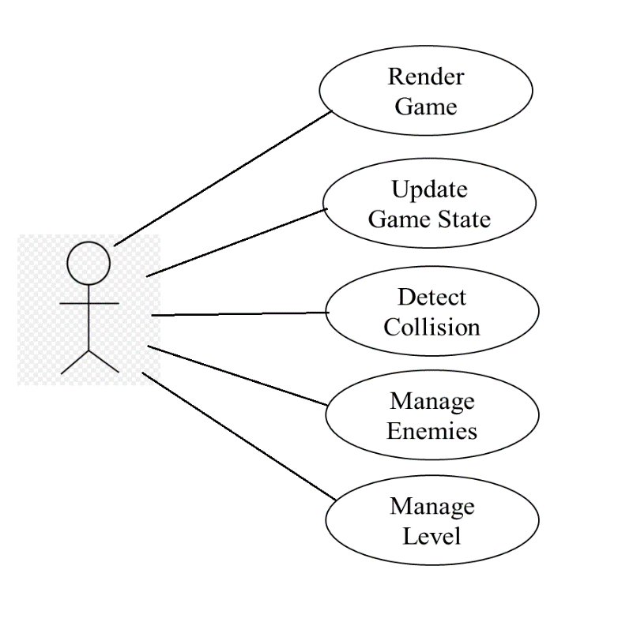

* 1. **MAJOR FUNCTIONALITY**

1. **Player Controls**

* Implementing responsive and intuitive controls for player movement, including walking, running, jumping, and crouching.
* Ensuring smooth and precise input handling to provide a seamless gameplay experience.

1. **Level Design**

* Designing well-crafted levels with various platforms, obstacles, and challenges that require precise player movement and timing to overcome.
* Balancing level difficulty to provide a satisfying progression curve, gradually introducing new mechanics and obstacles as the player advances.

1. **Collision Detection**

* Implementing accurate collision detection between the player character and the environment, including platforms, walls, and hazards.
* Handling collision responses, such as allowing the player to land on platforms, triggering actions upon collision with objects, and detecting collisions with enemies or hazards.

1. **Physics Simulation**

* Simulating realistic physics behaviors, such as gravity, momentum, and friction, to create natural and immersive movement for the player character.
* Integrating physics-based interactions, such as bouncing off surfaces, sliding down slopes, and pushing objects.

1. **Player Feedback**

Providing visual and auditory feedback to the player to communicate important game events, such as collecting items, defeating enemies, or reaching checkpoints.

Implementing visual indicators, animations, and sound effects to enhance the player's sense of accomplishment and progress.

These core functionalities form the foundation of a 2D platformer game, defining the player's experience and shaping the overall gameplay. They require careful design and implementation to ensure fluid movement, engaging level design, and a satisfying sense of challenge and accomplishment for the player.

1. **SYSTEM TESTING**

**6.1 TEST CASE**

|  |  |  |  |
| --- | --- | --- | --- |
| **Sl. No.** | **TEST CASE** | **USER** | **RESULT** |
| 1 | Player Movement: Move Left | Press the left arrow key to move left | Passed |
| 2 | Player Movement: Move Right | Press the right arrow key to move right | Passed |
| 3 | Player Jump: Jump Key Pressed | Press the spacebar key to make the player jump | Passed |
| 4 | Player Jump: Maximum Jump Height | Hold the spacebar key to reach maximum jump height | Passed |
| 5 | Collision Detection: Player Ground Collision | Move player character into a solid platform | Passed |
| 6 | Collision Detection: Player Wall Collision | Move player character into a vertical wall | Passed |
| 7 | Enemy Interaction: Player Collision with Enemy | Move player character into an enemy | Passed |
| 8 | Enemy Behavior: Enemy Movement | Observe enemy movement patterns | Passed |
| 9 | Level Progression: Reach End of Level | Navigate player character to the end of the level | Passed |
| 10 | UI Display: Health Bar Displayed | Observe the health bar on the screen | Passed |
| 11 | UI Interaction: Pause Menu | Press the 'esc' key to open the pause menu | Passed |
| 12 | UI Interaction: Restart Level Button | Click the restart button in the pause menu | Passed |
| 13 | Trivia Integration: Display Trivia Question | Answer the trivia question to clear level | Passed |

**6.2 SYSTEM MAINTENANCE**

For effective system maintenance of the Mind Maze: The 2D Platformer Quest:

**Bug Fixes:**

* Regularly identify and fix any bugs or issues reported by users or discovered through testing. This includes addressing issues related to gameplay mechanics, collision detection, rendering glitches, and user interface functionality.

**Performance Optimization:**

* Monitor and optimize the game's performance to ensure smooth gameplay on a variety of hardware configurations. This may involve optimizing rendering algorithms, reducing memory usage, and improving the efficiency of collision detection and physics simulations.

**Content Updates:**

* Keep the game fresh and engaging by periodically adding new levels, characters, items, and features. This may involve creating and integrating new assets produced in GIMP, such as sprites, backgrounds, and animations.

**Compatibility Updates:**

* Ensure the game remains compatible with the latest versions of Java and any third-party libraries or frameworks used in its development. Update dependencies as needed to address compatibility issues and security vulnerabilities.

**Security Patches:**

* Stay vigilant against potential security threats and vulnerabilities that could compromise the game or user data. Implement security patches and updates promptly to protect against common threats such as code injection, data tampering, and unauthorized access.

**Backup and Recovery:**

* Implement robust backup and recovery procedures to safeguard against data loss and corruption. Regularly backup game assets, source code, and user data, and test backup restoration procedures to ensure data integrity in the event of a system failure or data breach.

**Documentation Updates:**

* Keep documentation, including code comments, user manuals, and technical guides, up-to-date with any changes or additions made to the game. Clear and comprehensive documentation makes it easier for developers, users, and support staff to understand and maintain the game.

**Performance Monitoring:**

* Monitor key performance metrics, such as CPU and memory usage, frame rate, and network latency, to identify performance bottlenecks and optimize resource utilization. Use profiling tools and analytics to gain insights into how the game is performing and where improvements can be made.

By performing regular maintenance tasks and staying proactive in addressing issues and updates, you can ensure that your 2D platformer game remains enjoyable, reliable, and secure for players to enjoy over the long term.

**6.2.1 MAINTENANCE SCHEDULE**

* Regular maintenance activities will be scheduled and communicated to the team, with clear timelines and responsibilities assigned.
* Ad-hoc maintenance activities will be addressed on a case-by-case basis, with the issue triage process followed to prioritize and resolve them.

**7.CONCLUSION**

The development of our 2D platformer game using Java has been a journey marked by creativity, technical innovation, and a commitment to delivering an immersive gaming experience. Leveraging Java's object-oriented programming capabilities, we meticulously crafted modular and maintainable code structures to implement key game components such as collision detection, player movement, and enemy behaviors. The integration of GIMP for asset creation allowed us to infuse our game world with vibrant visuals and captivating animations, enhancing the overall immersion for players. Rigorous testing and quality assurance procedures ensured that the game delivers a polished and bug-free experience, while ongoing maintenance and support efforts will ensure its longevity and success. Ultimately, our 2D platformer game stands as a testament to our passion for game development and our dedication to crafting memorable experiences that bring joy to players worldwide.

**8.FUTURE ENHANCEMENTS**

1. **Additional Levels and Content:**

* Design and implement new levels with unique themes, challenges, and environments to provide players with fresh experiences and keep the game engaging.

1. **Power-Ups and Abilities:**

* Introduce power-ups and special abilities that players can collect throughout the game to enhance their character's abilities, such as temporary invincibility, speed boosts, or projectile attacks.

1. **Boss Battles:**

* Create epic boss battles at the end of each level or as standalone challenges, requiring players to use their skills and strategies to defeat powerful adversaries and progress in the game.

1. **Multiplayer Support:**

* Implement multiplayer functionality, allowing players to compete or cooperate with friends online or locally in co-op mode, adding a social dimension to the gameplay experience.

1. **Level Editor and User-Generated Content:**

* Develop a level editor tool that enables players to create and share their own custom levels, fostering community engagement and extending the game's longevity through user-generated content

1. **Expanded Storyline and Narrative:**

* Deepen the game's storyline with additional narrative elements, character development, and plot twists to immerse players in a rich and compelling narrative experience.

1. **Achievements and Progression Systems:**

* Integrate achievement systems and progression mechanics that reward players for completing challenges, reaching milestones, and mastering various aspects of the game, providing incentives for continued play.

1. **Accessibility Features:**

* **Incorporate accessibility features such as customizable controls, adjustable difficulty settings, and support for alternative input methods to ensure that the game is inclusive and enjoyable for all players.**

1. **Visual and Audio Enhancements:**

* Enhance the game's visuals with improved graphics, animations, and visual effects to create a more immersive and visually stunning experience.
* Expand the soundtrack with new music tracks, sound effects, and voiceovers to complement the gameplay and enhance the atmosphere.

1. **Cross-Platform Support:**

* Optimize the game for cross-platform compatibility, allowing players to enjoy the game on various devices and platforms, including mobile devices, and consoles.

**9.RESULTS**

**9.1 GANTT CHART**

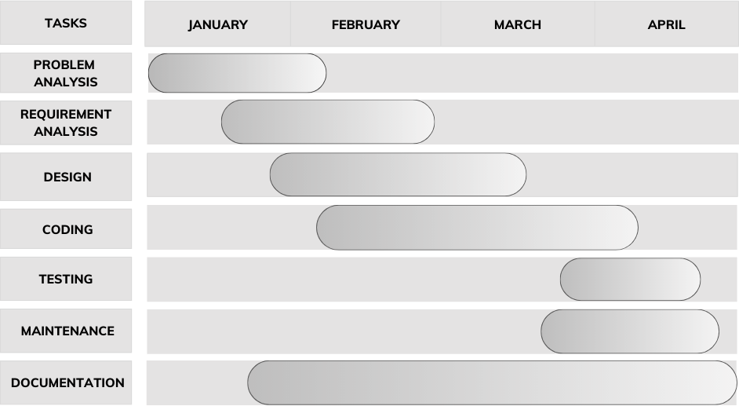

**9.2 SCREENSHOTS**

**9.2.1 HOME MENU**

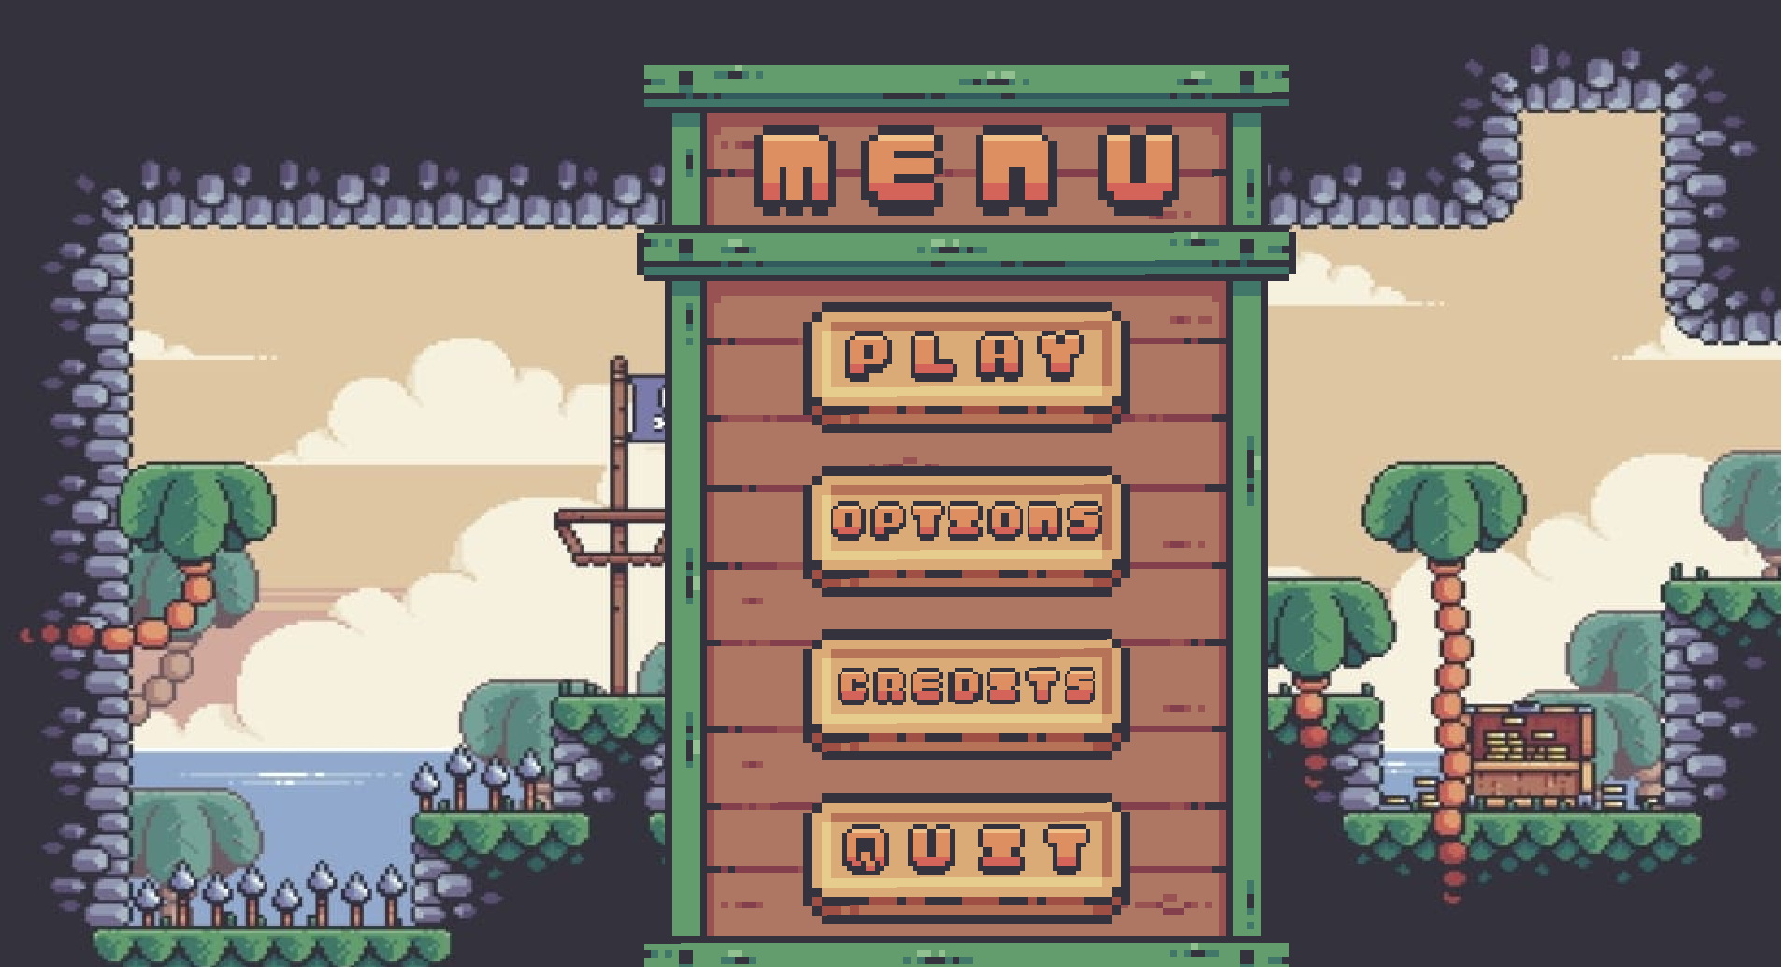

**9.2.2 OPTIONS MENU**

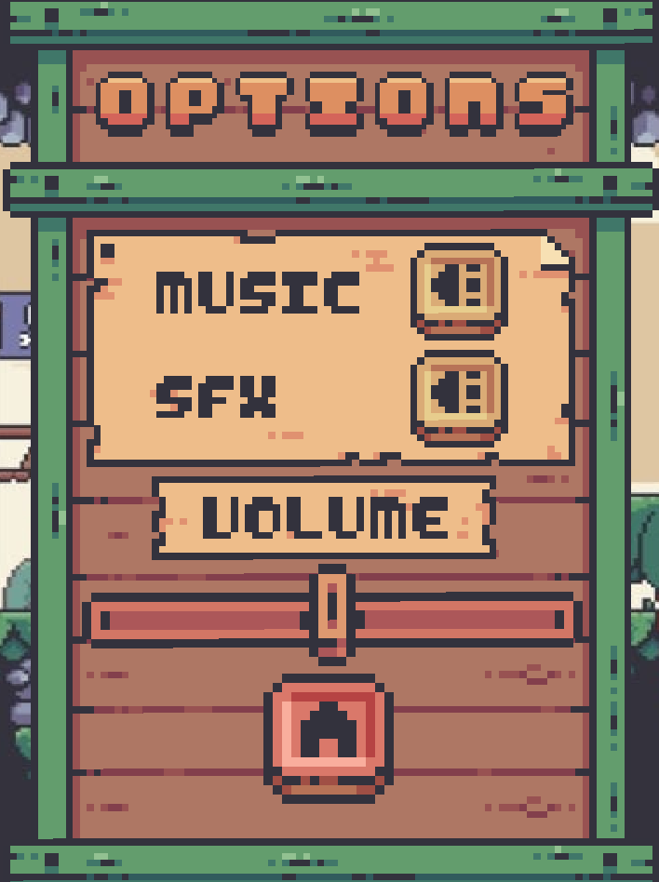

**9.2.3 LEVELS**

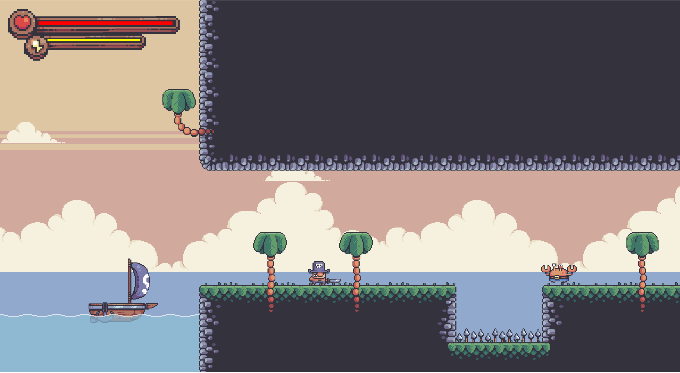

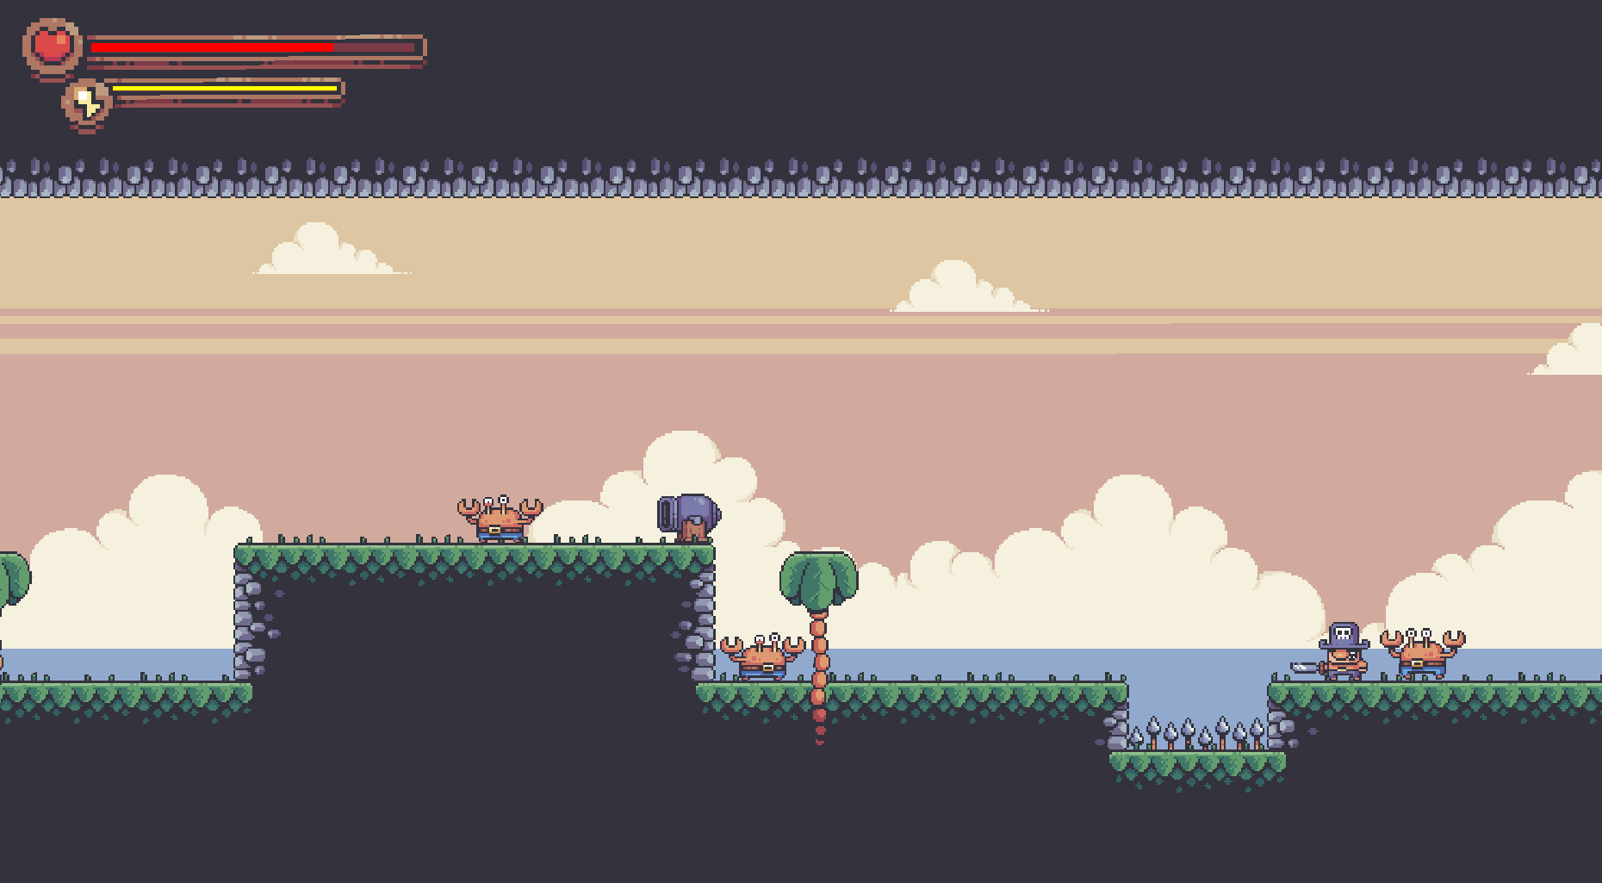

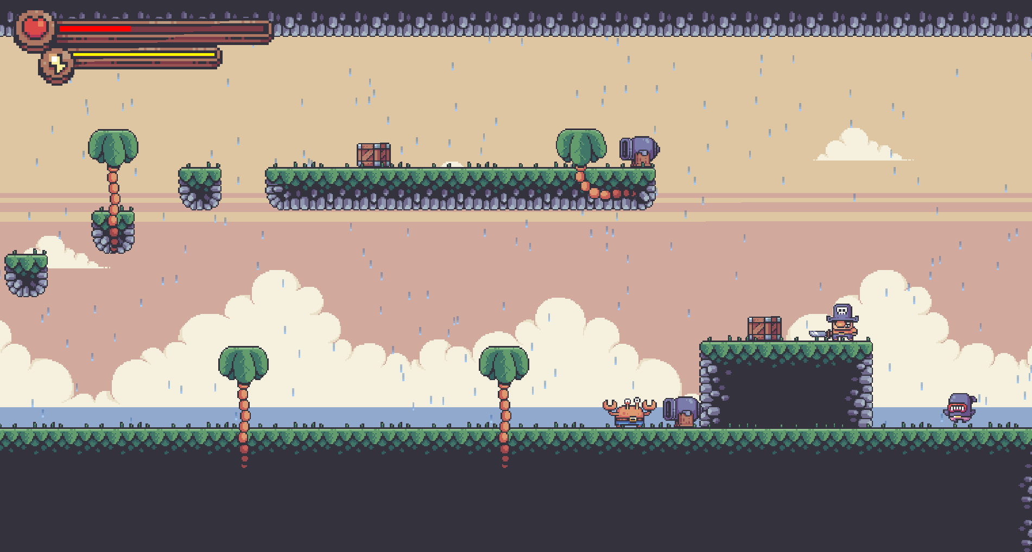

**9.2.4 OVERLAYS**

**PAUSE OVERLAY**

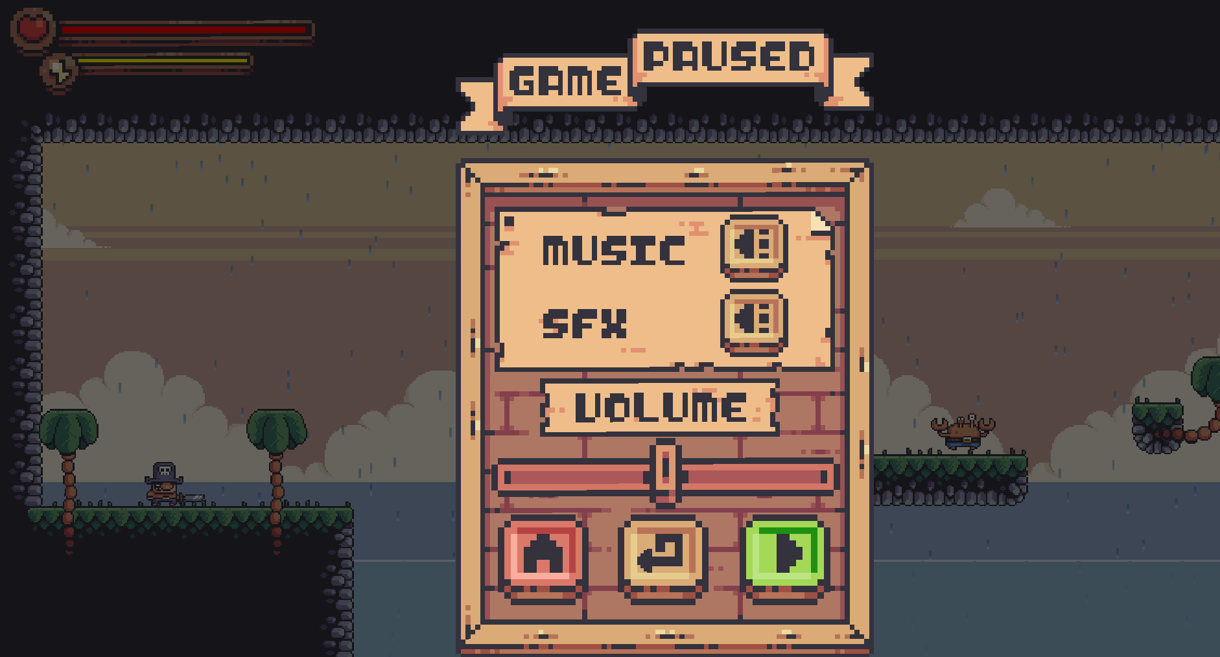

**LEVEL COMPLETED & FAILED OVERLAY**

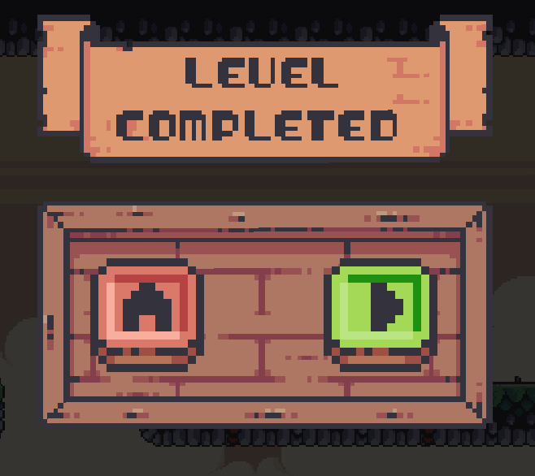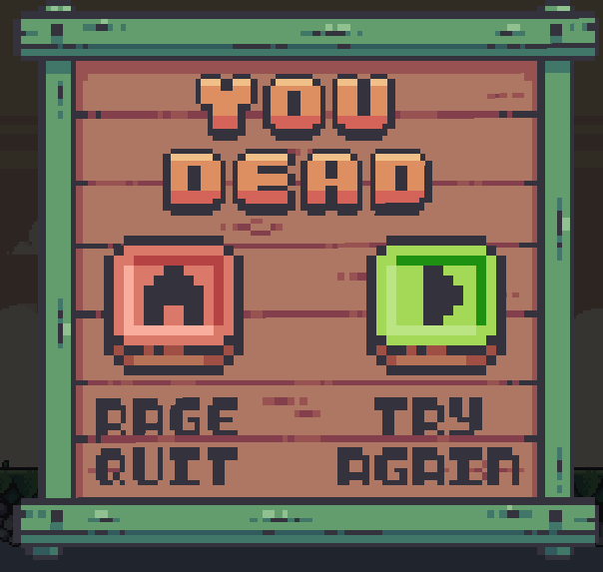

**10. BIBLIOGRAPHY**

1. GIMP Documentation Team. "GIMP User Manual." GIMP, 2020.
2. "TResaure Hunter Asset Pack" by PixelFrog. Available on itch.io: <https://pixelfrog-store.itch.io/resaure-hunter>
3. Schildt, Herbert. "JavaFX: A Beginner's Guide." McGraw-Hill Education, 2014.
4. “Songs by SUL “ Available on sul.itch.io” “Effects by Public Domain” Available on freesound.org

**11.REFERENCES**

[1] "Learning Java by Building Android Games: Explore Java Through Mobile Game Development" by John Horton (2015).

[2] "Pro Java 9 Games Development: Leveraging the JavaFX APIs" by Wallace Jackson (2017).

[3] "Introduction to Java Programming and Data Structures: Comprehensive Version" by Y. Daniel Liang (2019).

[4] "Beginning Java Game Development with LibGDX" by Lee Stemkoski (2015).

[5] "Killer Game Programming in Java" by Andrew Davison (2005).

[6] "Java Game Development with LibGDX: From Beginner to Professional" by Lee Stemkoski (2014).

[7] "Sams Teach Yourself Java in 21 Days" by Rogers Cadenhead (2018).

[8] "Java: A Beginner's Guide" by Herbert Schildt (2018).

[9] Adams, Ernest. "Fundamentals of Game Design." New Riders, 2009.

[10] Github Repository : <https://github.com/JordanAbraham/MCA_Major_Project.git>